FAIRY GROVE 5 YEAR MAINTENANCE PLAN

Fairy Grove is a single storey detached property built in 1998. It is 521 square metres, (c. 5,600 sq. ft), and has 8 bedrooms, 3 bathrooms plus an additional 2 toilets. It currently houses 6 residents.

EPC
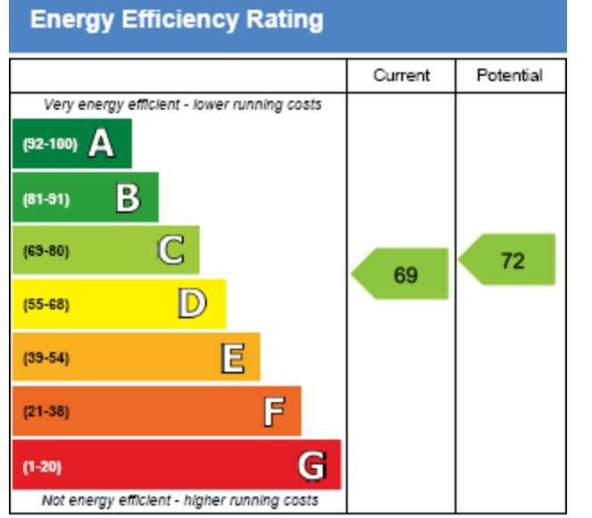
The EPC rating of the house is currently at grade C, which is above the average rating for Northern Ireland. This is likely down to the recently renewed gas boiler, as well as a reasonable level of loft insulation already present in the building.
This is an example of a property which is already almost meeting its potential rating. Therefore, the 5-year plan does not need to take an immediate focus on energy saving measures and can be tailored to meet more of the requests which we have received from the community.

5 Year Plan
The proposed 5-year plan refers to the following:
- Stock Condition Survey 2024
- Results of EPC ratings
- Annual CHA staff stock condition review
- Discussions with residents and care staff

YEAR | DESCRIPTION OF WORKS | RECOMMENDATION BY | COST ESTIMATE | NOTES
1 | Replace timber windows and doors with UPVC. | CHA & stock condition survey. | £36,000 | SCS estimate seems low.
2 | Replacement rainwater goods, fascia & soffit. | CHA. | £30,000
3 | External redecoration. | CHA & stock condition survey. | £6,000 | SCS estimate seems low.
3 | Replacement bathroom | CHA & stock condition survey. | £7,500 | SCS estimate seems low.
 |  |  | Total: £79,500

