NOVALIS 5 YEAR PLAN

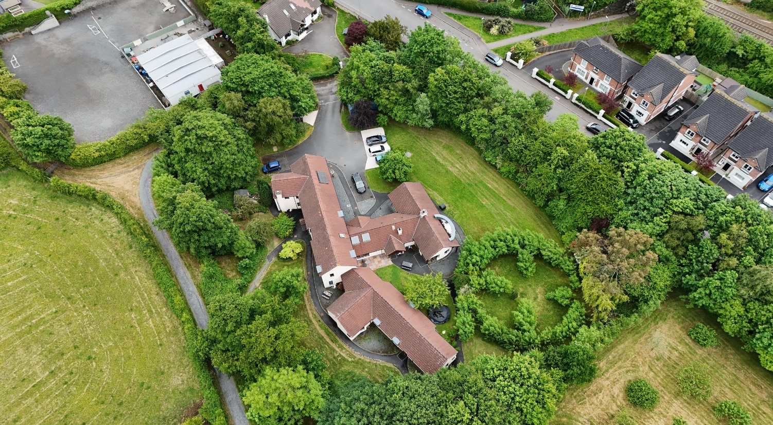

Novalis is a 2-storey detached property built in 1999. It is 442 square metres (c. 4,800 sq. ft), and has 12 bedrooms, 4 bathrooms plus an additional 2 toilets. It currently houses 6 residents.

EPC

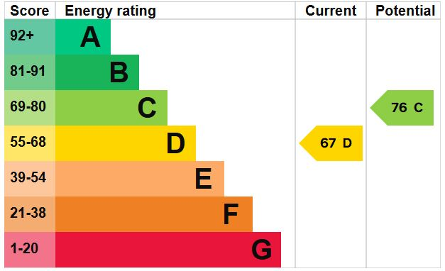
The EPC rating of the house is currently at grade D, which is in line with the average rating for Northern Ireland. The potential rating is C, and this can be achieved by implementing the recommendations set out in the EPC survey which were also recommended in the stock condition survey carried out by Moore MacDonald.
The EPC recommendations include upgrading windows and external doors, upgrading loft insulation and replacing the existing boiler with a more modern, energy efficient type.

5 Year Plan
The proposed 5-year plan refers to the following:
- Stock Condition Survey 2024
- Results of EPC ratings
- Annual CHA staff stock condition review
- Discussions with residents and care staff

YEAR | DESCRIPTION OF WORKS | COST ESTIMATE
1 | Upgrade bathroom | £8,500
2 | Loft insulation upgrade | £3,000
2 | Upgrade existing timber windows and doors to UPVC | £70,000
3 | Redecoration of internal communal areas | £9,500
3 | External redecoration | £9,500
3 | Upgrade existing fascia, soffit & rainwater goods | £15,000
4 | Replacement of existing boiler with a more modern energy efficient type. | £15,000
5 | Smoke & Heat detector upgrade (This will be monitored through annual service records and will be brought forward if necessary). | £9,600
5 | Landscaping of external flower beds | £5,000
 |  | Total: £145,100

